Create Table Employee Details:

[CREATE](http://localhost/phpmyadmin/url.php?url=https://dev.mysql.com/doc/refman/8.0/en/create-table.html) [TABLE](http://localhost/phpmyadmin/url.php?url=https://dev.mysql.com/doc/refman/8.0/en/create-table.html) Employee_Details(Emp_id int(4),Full_Name varchar(20),Manager_id int(4),DateofJoining varchar(15));

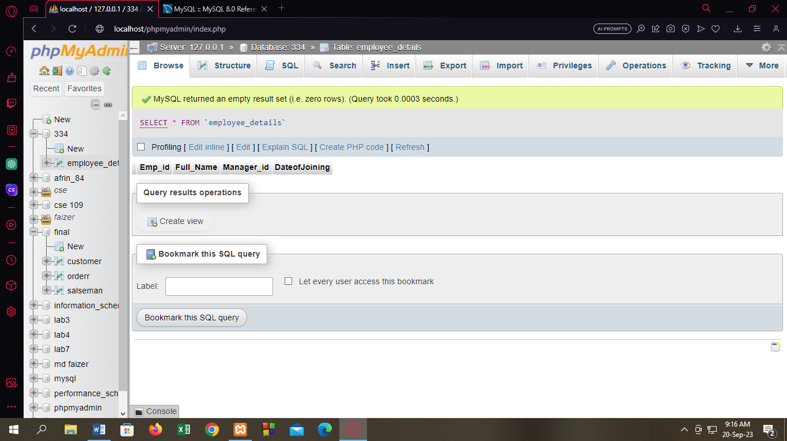

Create Table Employee Salary:

[CREATE](http://localhost/phpmyadmin/url.php?url=https://dev.mysql.com/doc/refman/8.0/en/create-table.html) [TABLE](http://localhost/phpmyadmin/url.php?url=https://dev.mysql.com/doc/refman/8.0/en/create-table.html) Employee_Salary(Emp_id int(4),Project varchar(10),Salary varchar(12));

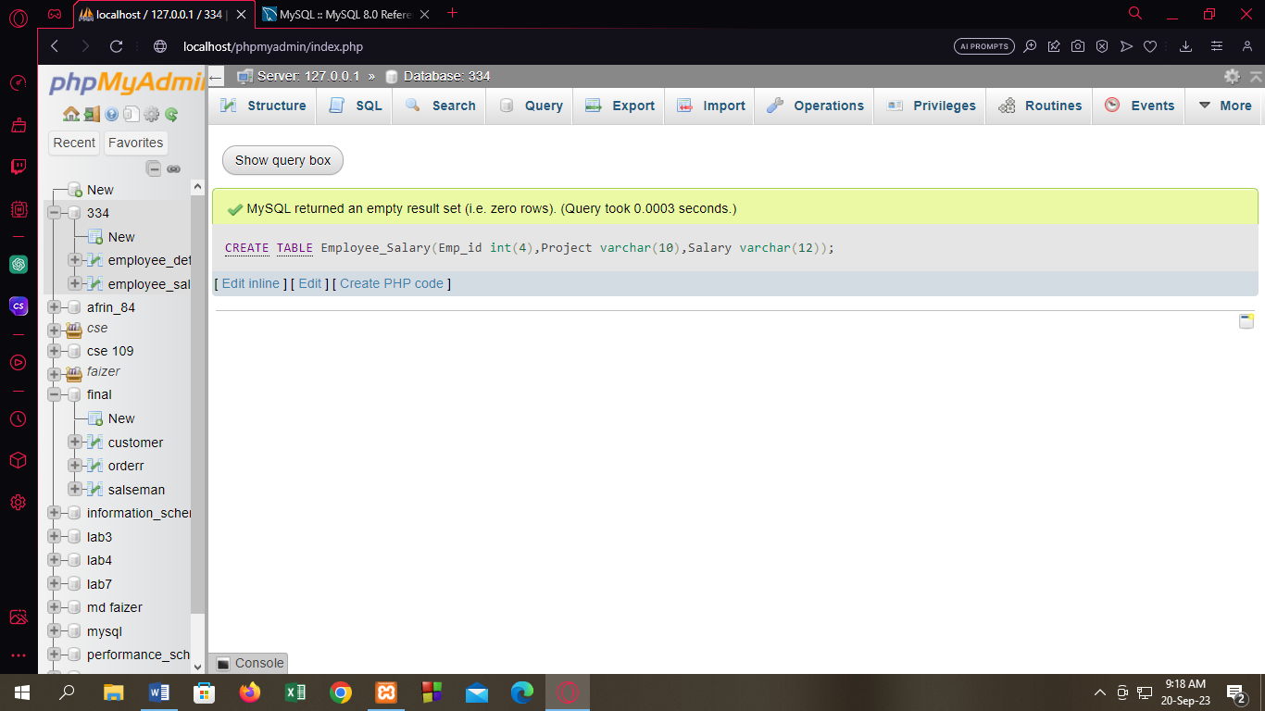

Insert Data into Employee Details:

[INSERT](http://localhost/phpmyadmin/url.php?url=https://dev.mysql.com/doc/refman/8.0/en/insert.html) INTO employee_details VALUE('121','John Snow',"321","01/31/2014");

INSERT INTO employee_details VALUE('321','Walter White',"966","01/30/2015");

INSERT INTO employee_details VALUE('421','Kuldeep rana',"876","27/11/2016");

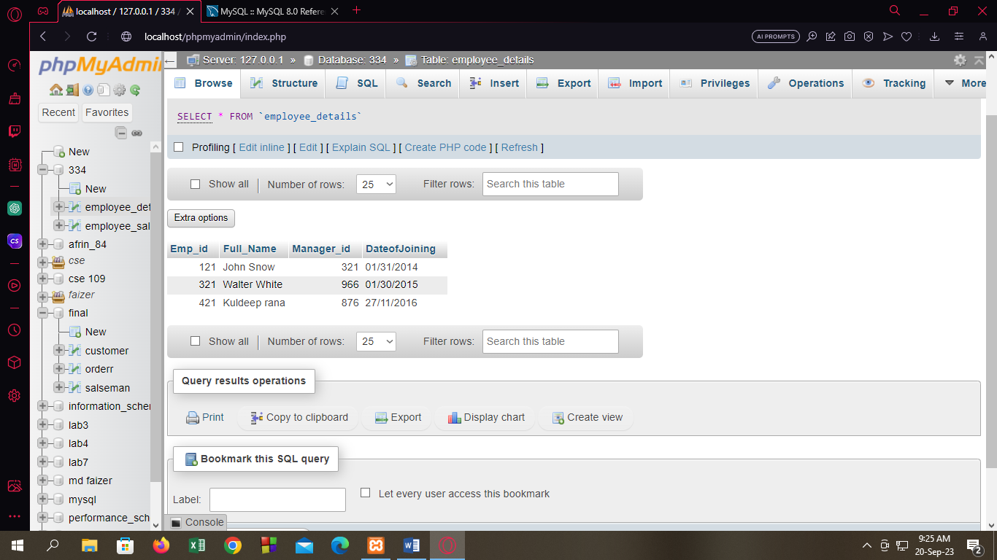

Insert Data into Employee Salary:

[INSERT](http://localhost/phpmyadmin/url.php?url=https://dev.mysql.com/doc/refman/8.0/en/insert.html) INTO employee_salary VALUE('121',"P1",'8000');

Top of Form

Bottom of Form

[ [Edit inline](http://localhost/phpmyadmin/index.php?route=/table/sql&db=334&table=employee_salary) ] [ [Edit](http://localhost/phpmyadmin/index.php) ] [ [Create PHP code](http://localhost/phpmyadmin/index.php) ]

http://localhost/phpmyadmin/themes/dot.gif 1 row inserted. (Query took 0.0082 seconds.)

[INSERT](http://localhost/phpmyadmin/url.php?url=https://dev.mysql.com/doc/refman/8.0/en/insert.html) INTO employee_salary VALUE('321',"P2",'1000');

Top of Form

Bottom of Form

[ [Edit inline](http://localhost/phpmyadmin/index.php?route=/table/sql&db=334&table=employee_salary) ] [ [Edit](http://localhost/phpmyadmin/index.php) ] [ [Create PHP code](http://localhost/phpmyadmin/index.php) ]

http://localhost/phpmyadmin/themes/dot.gif 1 row inserted. (Query took 0.0002 seconds.)

[INSERT](http://localhost/phpmyadmin/url.php?url=https://dev.mysql.com/doc/refman/8.0/en/insert.html) INTO employee_salary VALUE('421',"P1",'12000');

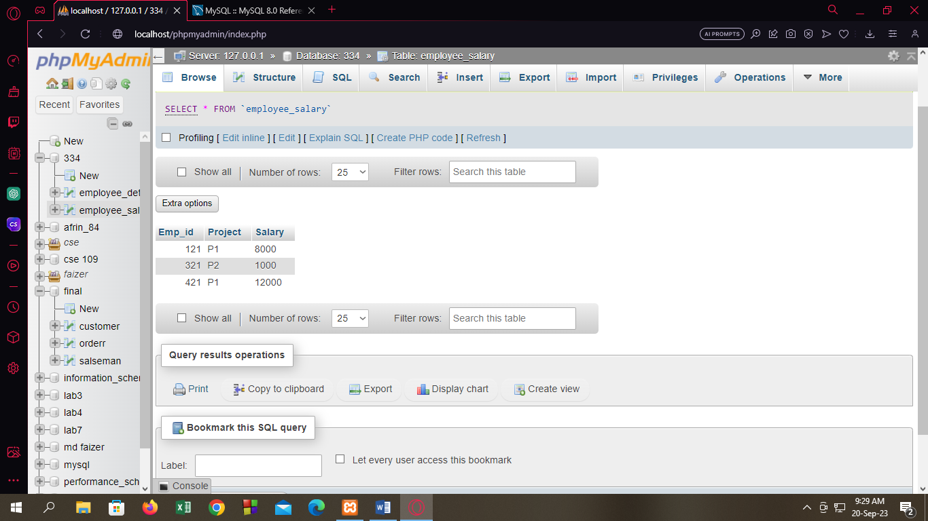

Q1:

[SELECT](http://localhost/phpmyadmin/url.php?url=https://dev.mysql.com/doc/refman/8.0/en/select.html) [COUNT](http://localhost/phpmyadmin/url.php?url=https://dev.mysql.com/doc/refman/8.0/en/aggregate-functions.html%23function_count)(Project) FROM employee_salary WHERE Project="P1";

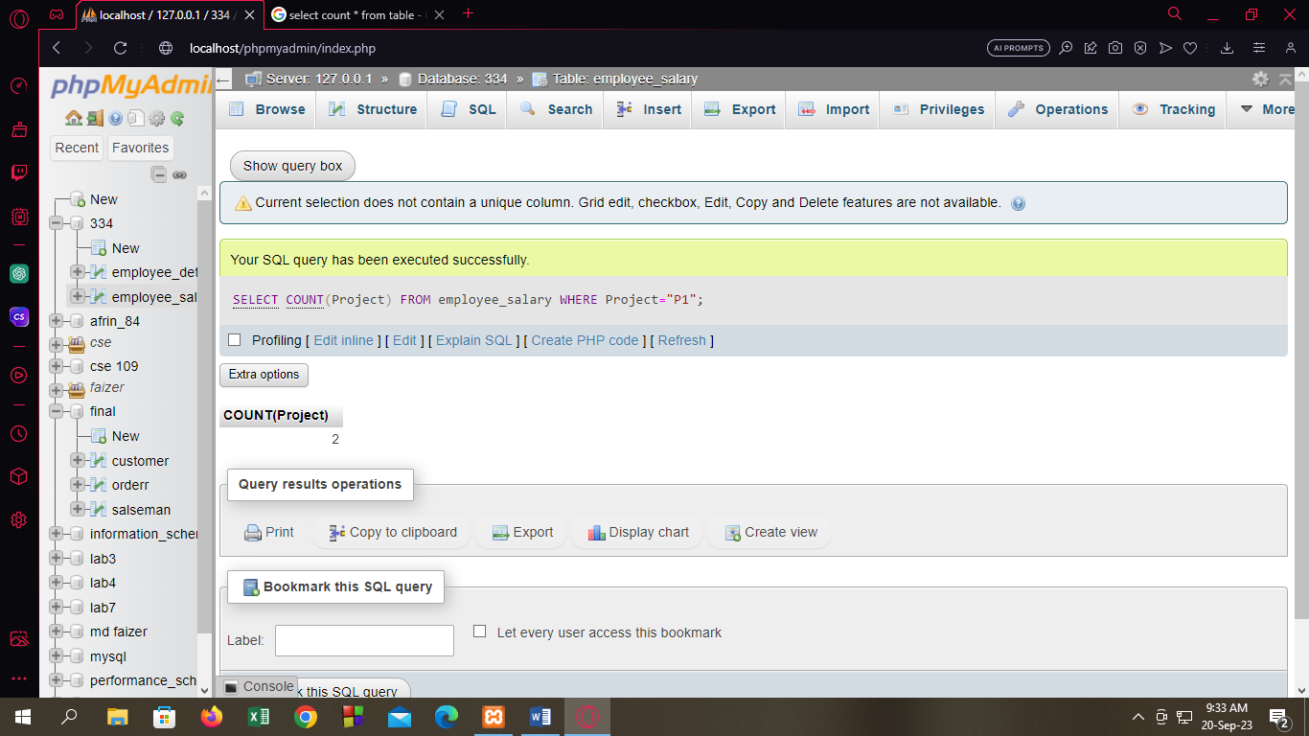

Q2:

[SELECT](http://localhost/phpmyadmin/url.php?url=https://dev.mysql.com/doc/refman/8.0/en/select.html) Full_Name FROM employee_details NATURAL JOIN employee_salary WHERE Salary>=(Salary*12);

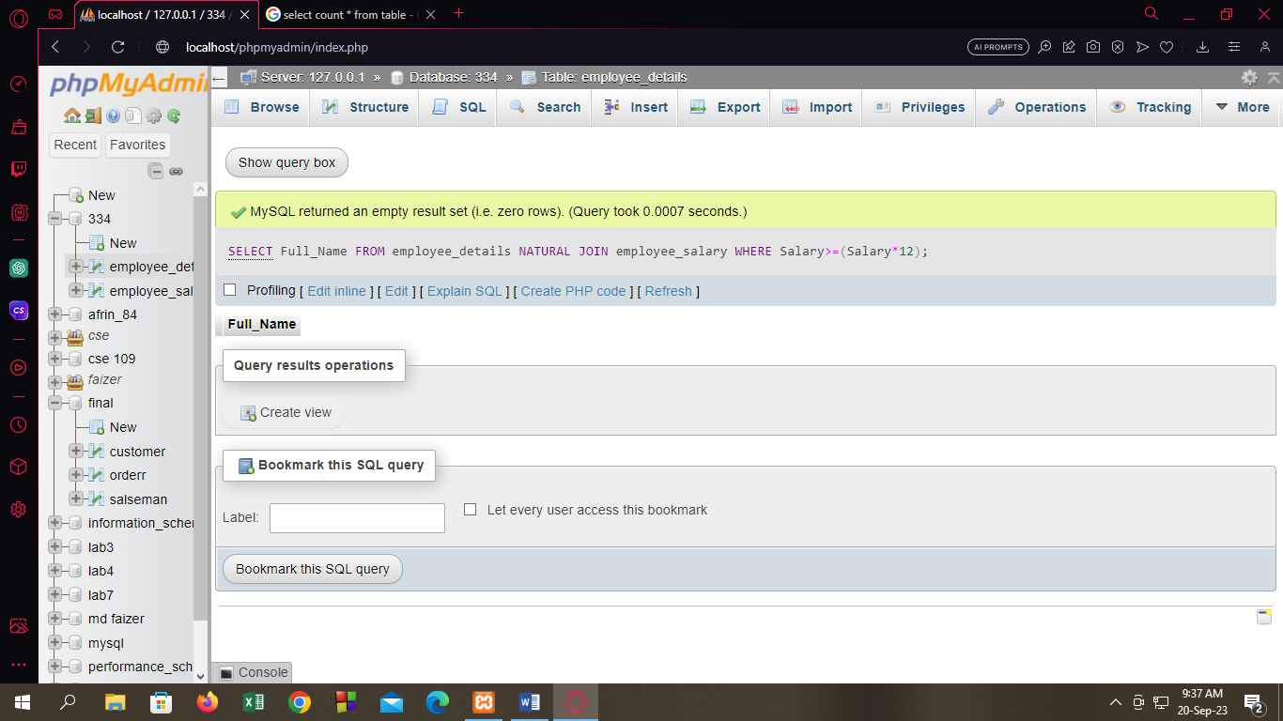

Q3:

[SELECT](http://localhost/phpmyadmin/url.php?url=https://dev.mysql.com/doc/refman/8.0/en/select.html) [COUNT](http://localhost/phpmyadmin/url.php?url=https://dev.mysql.com/doc/refman/8.0/en/aggregate-functions.html%23function_count)(Emp_id) FROM employee_salary GROUP BY Project;

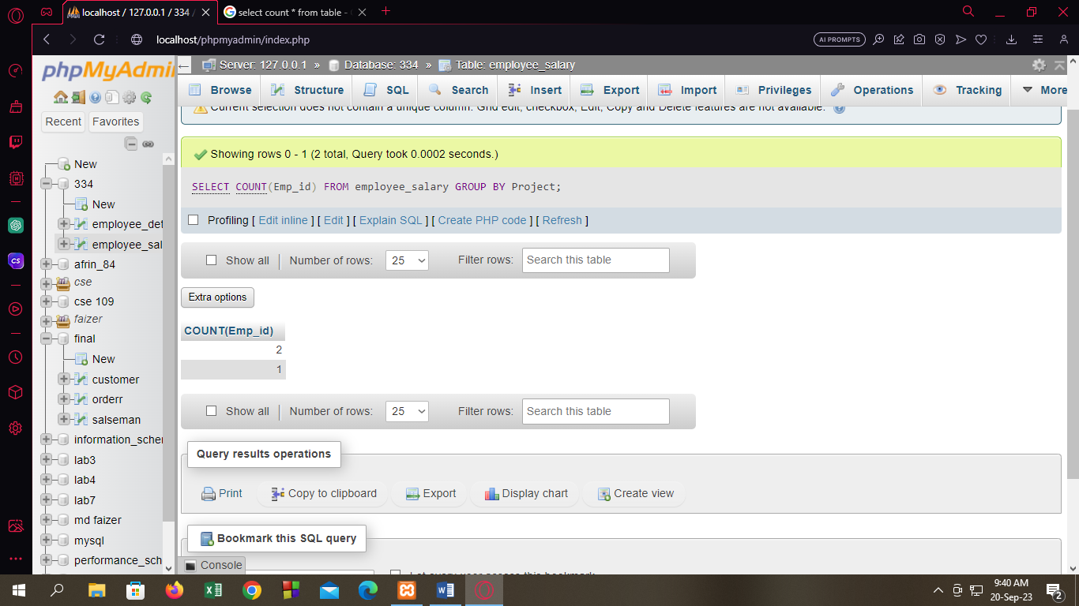

Q4:

[SELECT](http://localhost/phpmyadmin/url.php?url=https://dev.mysql.com/doc/refman/8.0/en/select.html) * FROM employee_details NATURAL [LEFT](http://localhost/phpmyadmin/url.php?url=https://dev.mysql.com/doc/refman/8.0/en/string-functions.html%23function_left) OUTER JOIN employee_salary;

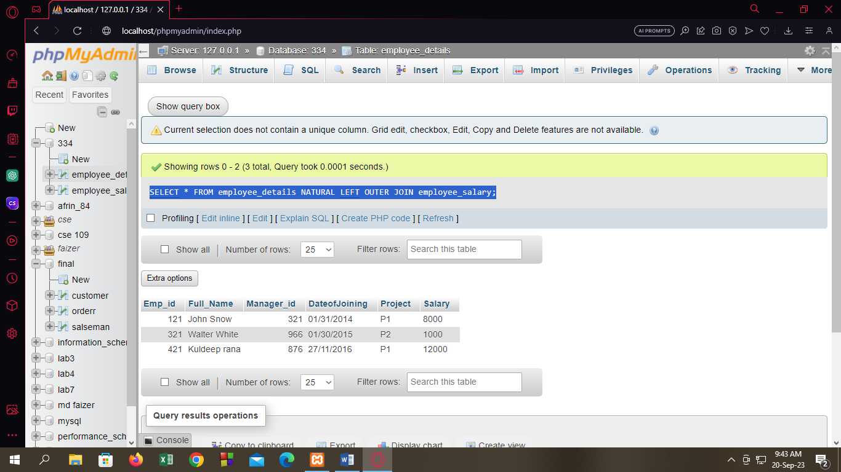

[SELECT](http://localhost/phpmyadmin/url.php?url=https://dev.mysql.com/doc/refman/8.0/en/select.html) * FROM employee_details NATURAL [RIGHT](http://localhost/phpmyadmin/url.php?url=https://dev.mysql.com/doc/refman/8.0/en/string-functions.html%23function_right) OUTER JOIN employee_salary;

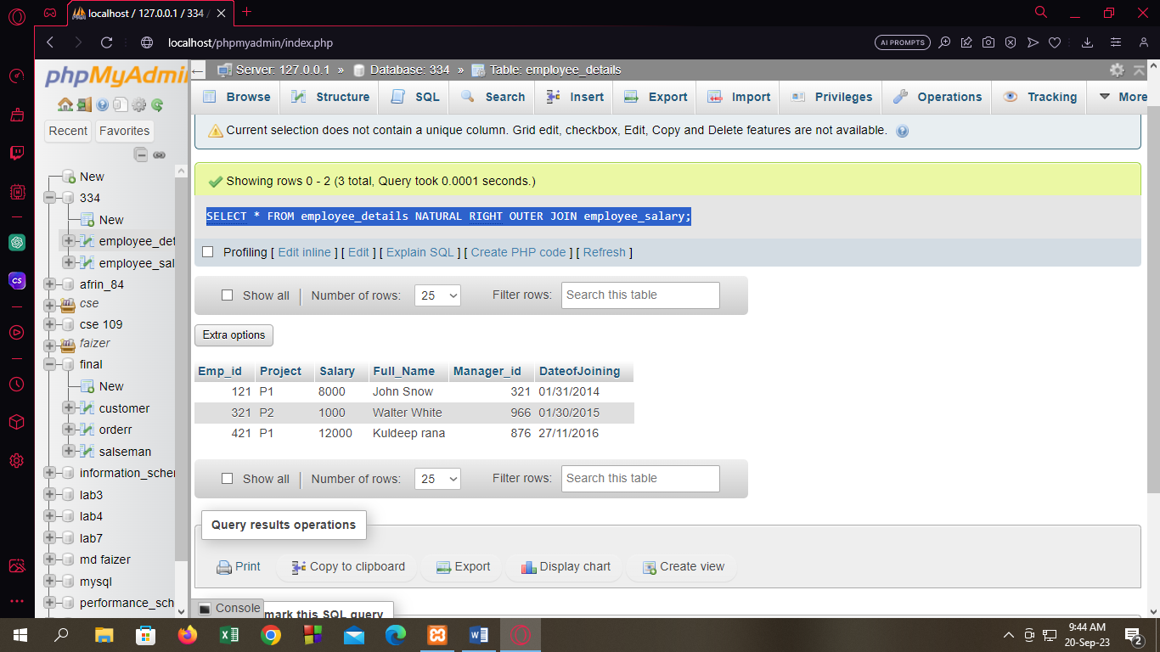

Q5:

[SELECT](http://localhost/phpmyadmin/url.php?url=https://dev.mysql.com/doc/refman/8.0/en/select.html) * FROM employee_details WHERE DateofJoining="27/11/2016";

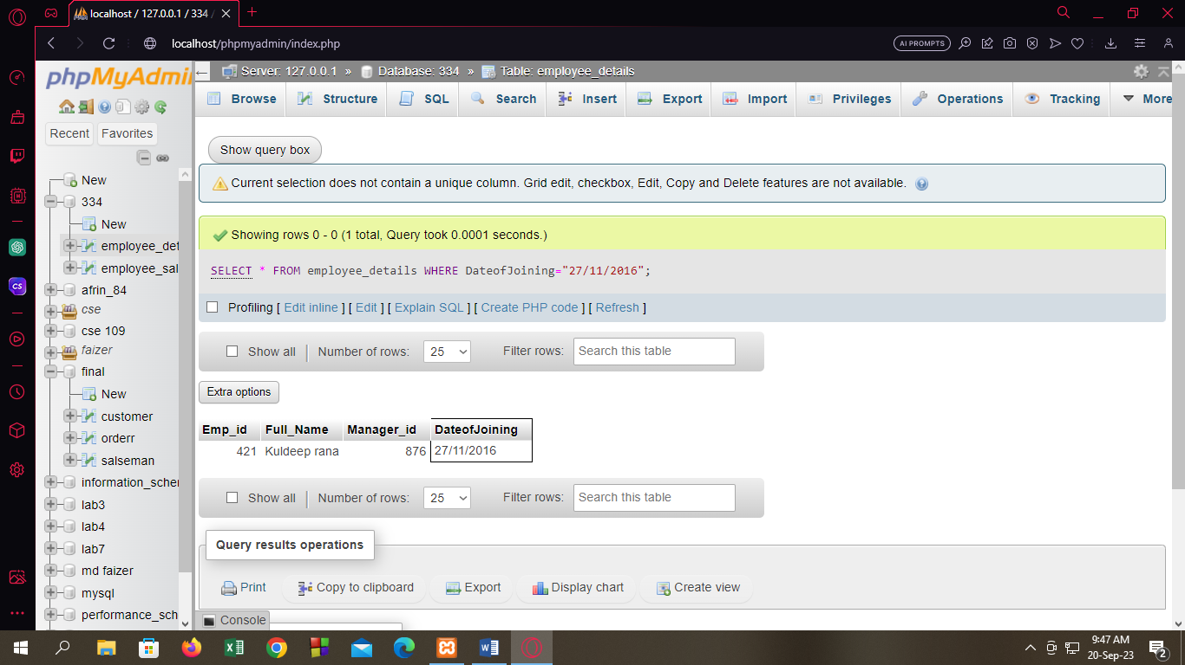

Q6:

[SELECT](http://localhost/phpmyadmin/url.php?url=https://dev.mysql.com/doc/refman/8.0/en/select.html) * FROM employee_details WHERE Full_Name [LIKE](http://localhost/phpmyadmin/url.php?url=https://dev.mysql.com/doc/refman/8.0/en/string-comparison-functions.html%23operator_like) "%ee%";

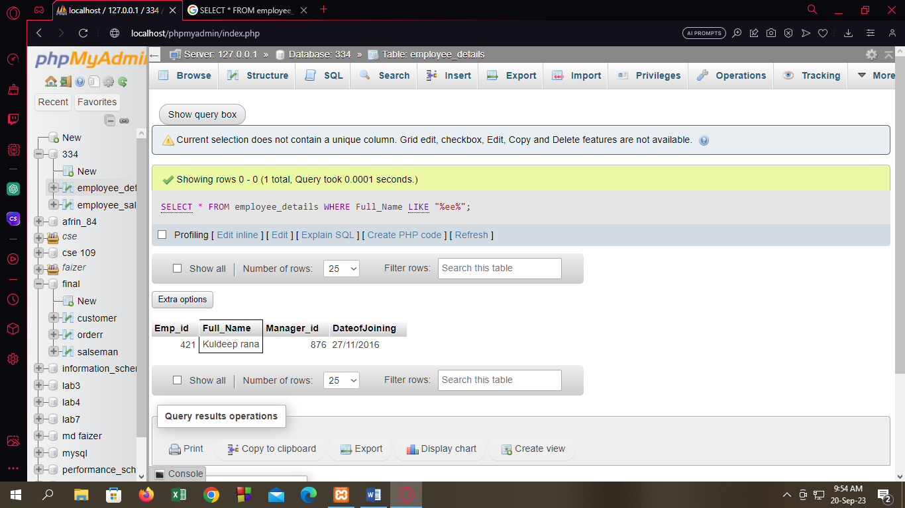

Q7:

[SELECT](http://localhost/phpmyadmin/url.php?url=https://dev.mysql.com/doc/refman/8.0/en/select.html) SUBSTR(Full_Name,1,3) FROM employee_details;

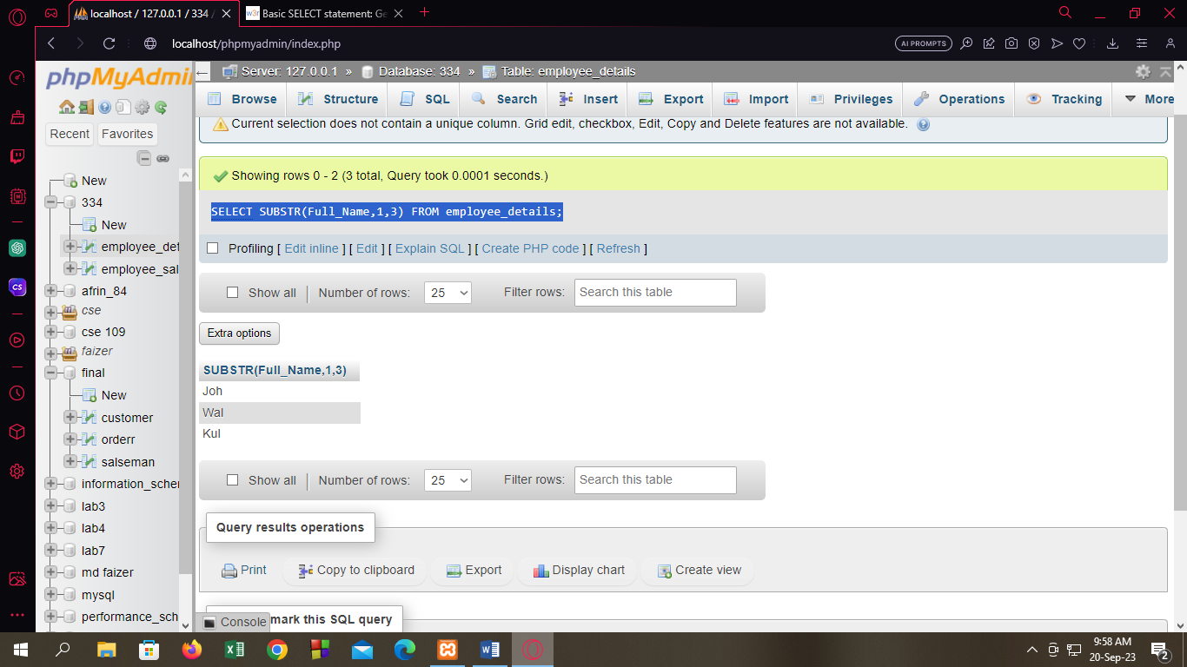

Q8:

[UPDATE](http://localhost/phpmyadmin/url.php?url=https://dev.mysql.com/doc/refman/8.0/en/update.html) employee_details [SET](http://localhost/phpmyadmin/url.php?url=https://dev.mysql.com/doc/refman/8.0/en/set.html) Emp_id=212 WHERE Manager_id='321';

